Number Guessing Game



Name: MUKESH ARAV V
Reg. No: 711525BCS097
Class & Section: CSE - B
GitHub Link:

📌Project Overview – Number Guessing Game in C
This mini-project implements a Number Guessing Game in C with two main game modes:
1️⃣ Survival Mode
- The player must guess the secret random number within a limited number of attempts.
- Difficulty levels change:
  - Number range
  - Allowed attempts
2️⃣ Timer Mode
- The player must guess the number before the time limit expires.
- Each difficulty level has a different:
  - Range of numbers
  - Total time limit
✨ Additional Features
- Input validation (no crashing on wrong input)
- Difficulty selection
- Replay option for each mode
- Random number generation using system time
- Clear feedback (“HIGH”, “LOW”, “CORRECT”)
This program demonstrates:
- Functions
- Loops
- Conditionals
- Modular programming
- Time handling (time.h)
- Random numbers (rand())
- User-input validation

✅ 📌 ALGORITHM (Step-by-Step)
Use this in your mini-project report.

✨Algorithm: Number Guessing Game
Start
- Begin the program.
- Initialize random seed using srand(time(NULL)).
- Display main menu:

    - Survival Mode🛡️
    - Timer Mode️
    - Exit⬅️

Main Loop
- Read user’s choice using validated input (Check_input_int()).

If choice = 1 → Survival Mode
- Display difficulty options:
  - Easy (1–40, 10 attempts)
  - Medium (1–400, 8 attempts)
  - Hard (1–4000, 6 attempts)
  - Impossible (1–32767, 4 attempts)
- User selects difficulty → set:
  - Random number (using rand())
  - Allowed attempts
- Call function → Check_rand_numb(random, attempts)
  - Repeat until:
    - User guesses correct number
    - OR attempts become zero
- Display result (WIN / LOSE).
- Ask user if they want to play Survival Mode again.

If choice = 2 → Timer Mode
- Display difficulty options:
- Easy → 240 seconds
- Medium → 180 seconds
- Hard → 120 seconds
- Impossible → 60 seconds
- User selects difficulty → set:
- Random number
- Time limit
- Start timer using:
start = time(NULL)
- Call → Check_rand_numb_timer(random, time_limit)
- After every guess:
  - Check HIGH or LOW
- Continuously check:
- if (current_time - start >= time_limit)
- show timeout message
- Display result (WIN / TIME UP).
- Ask user if they want to play Timer Mode again.

If choice = 3 → Exit
- Display exit message.
- Terminate program.

Validation Functions Used
Check_input_int()
- Ensures the user enters a valid integer.
- Rejects alphabets/symbols.
Check_input_yn()
- Accepts only 'y', 'Y', 'n', 'N'.
- Used for replay prompts.

✅ 📌 Overview of Each Function (For Documentation)
1. main ()
- Controls the overall game flow.
- Shows main menu.
- Calls game mode functions.
- Handles replay loops.

2. Survival_Mode ()
- Displays difficulty levels.
- Generates random number.
- Selects number of attempts.
- Calls number-checking function.

3. Timer_Mode ()
- Displays difficulty levels.
- Sets time limits.
- Uses time () and difftime () to count elapsed time.
- Calls timer-based number checking function.

4. Check_rand_numb (int rand, int attempt)
- Used for Survival Mode.
- Compares user guess with secret number.
- Shows HINTS (“HIGH”, “LOW”).
- Stops when:
  - User guesses correctly
  - OR attempts run out

- Check_rand_numb_timer (int rand,
int time_limit)
- Used for Timer Mode.
- Continuously checks time limit.
- Stops when:
  - Correct guess
  - OR time expires

6. Check_input_int ()
- Reads valid integer input.
- Prevents program from crashing if letters are entered.

7. Check_input_yn ()
- Accepts only YES/NO characters.
- Ensures clean user interaction.

SOURCE CODE:

#include <stdio.h>
#include <stdlib.h>
#include <time.h>

void Survival_Mode();
void Timer_Mode();
void Check_rand_numb(int rand_numb,int attempt);
void Check_rand_numb_timer(int rand_numb,int time_limit);
int Check_input_int();
char Check_input_yn();

//main function

int main(){ //main function
srand(time(NULL));
printf("\t--------Welcome To Number Guessing Game--------\t\n");
char loop_1;
do{
char loop_2;
printf("\n\t[1] Survival Mode.\n\t[2] Timer Mode.\n\t[3] Exit.\n\n");
printf("Enter your choice : ");
int choice_1=Check_input_int();
switch(choice_1){
case 1:{
do{
Survival_Mode();
printf("\nDo you want to continue the Survival Mode Enter (y) or Enter (n) :");
loop_2=Check_input_yn();
if(loop_2 == 'y' || loop_2 == 'Y') continue;
else if(loop_2 == 'n' || loop_2 == 'N') break;
}while(1);
break;
}case 2:{
do{
Timer_Mode();
printf("\nDo you want to continue the Timer Mode Enter (y) or Enter (n) :");
loop_2=Check_input_yn();
if(loop_2 == 'y' || loop_2 == 'Y') continue;
else if(loop_2 == 'n' || loop_2 == 'N') break;
}while(1);
break;
}case 3:{
printf("Exiting the GAME.......\n");
break;
}default:
printf("\n\t...Invalid Entry...\n");
}
printf("\nDo you want to continue the GAME Enter (y) or Enter (n) :");
loop_1=Check_input_yn();
if(loop_1 == 'y' || loop_1 == 'Y') continue;
else if(loop_1 == 'n' || loop_1 == 'N') break;
}while(1);
}

//Input function checks the given input is correct or not

int Check_input_int(){
int number;
while(1){
if((scanf("%d",&number)==1)){ //here i gava like ==1 because if scaf gets int as a input means it returns 1.
return number; //for char scanf return 0.
}else{
printf("\nEnter VALID input : ");
while(getchar()!='\n'); //remove the invalid input
}
}
}

//Input function checks the give input is y or n or other

char Check_input_yn() {
char ch;
while (1) {
if (scanf(" %c", &ch) == 1) {
if (ch == 'y' || ch == 'Y' || ch == 'n' || ch == 'N') return ch;
else printf("\nEnter VALID input (y/n): ");
} else printf("\nEnter VALID input (y/n): ");
while (getchar() != '\n');
}
}

//function 1

void Survival_Mode(){ //Survival mode function
printf("\n\t--------You are in Survival Mode--------\t\n");
printf("\t[1] Easy (1-40).\n\t[2] Medium (1-400).\n\t[3] Hard (1-4000).\n\t[4] Impossible(Mystry Round) (1-32767).\n\t[5] Exit.\n\n");
printf("Enter your choice : ");
int choice_2=Check_input_int();
switch(choice_2){
case 1:{
int rand_numb_easy=(rand()%40)+1;
int attempt_easy=10;
Check_rand_numb(rand_numb_easy,attempt_easy);
break;
}case 2:{
int rand_numb_medium=(rand()%400)+1;
int attempt_medium=8;
Check_rand_numb(rand_numb_medium,attempt_medium);
break;
}case 3:{
int rand_numb_hard=(rand()%4000)+1;
int attempt_hard=6;
Check_rand_numb(rand_numb_hard,attempt_hard);
break;
}case 4:{
int rand_numb_imp=(rand()%(32767))+1;
int attempt_imp=4;
Check_rand_numb(rand_numb_imp,attempt_imp);
break;
}case 5:{
printf("Exiting the Survival Mode.......\n");
break;
}
}
}

//function 2

void Timer_Mode(){ //Timer mode function
printf("\n\t--------You are in Timer Mode--------\t\n");
printf("\t[1] Easy (1-40).\n\t[2] Medium (1-400).\n\t[3] Hard (1-4000).\n\t[4] Impossible(Mystry Round) (1-32767).\n\t[5] Exit.\n\n");
printf("Enter your choice : ");
int choice_2=Check_input_int();
switch(choice_2){
case 1:{
int rand_numb_easy=(rand()%40)+1;
int time_easy=240;
printf("\n\t----Your Time Limit is %d ----\t\n",time_easy);
Check_rand_numb_timer(rand_numb_easy,time_easy);
break;
}case 2:{
int rand_numb_medium=(rand()%400)+1;
int time_medium=180;
printf("\n\t----Your Time Limit is %d ----\t\n",time_medium);
Check_rand_numb_timer(rand_numb_medium,time_medium);
break;
}case 3:{
int rand_numb_hard=(rand()%4000)+1;
int time_hard=120;
printf("\n\t----Your Time Limit is %d ----\t\n",time_hard);
Check_rand_numb_timer(rand_numb_hard,time_hard);
break;
}case 4:{
int rand_numb_imp=rand()%(32767)+1;
int time_imp=60;
printf("\n\t----Your Time Limit is %d ----\t\n",time_imp);
Check_rand_numb_timer(rand_numb_imp,time_imp);
break;
}case 5:{
printf("Exiting the Timer Mode.......\n");
break;
}
}
}
//function 3
void Check_rand_numb(int rand_numb,int attempt){ //it will check for Survival mode
int user_numb;
int s_a=attempt;
while(attempt>0){
printf("\n--------ONLY %d ATTEMPTS--------\n",attempt);
printf("Enter your guess : ");
user_numb=Check_input_int();
if(user_numb>rand_numb){
printf("\n ....HIGH....\n");
}else if(user_numb<rand_numb){printf("\n ....LOW....\n");
}else {
printf("\n*Excellent, You Nailed it\n");
printf("YOUR SCORE : %d / %d\n",attempt,s_a);
return;
}attempt--;
}
printf("\nYOU LOSE...\n");
printf("\n\t----The Answer is %d ----",rand_numb);
}
//function 4
void Check_rand_numb_timer(int rand_numb,int time_limit){ //it will check for Timer mode
int user_numb;
time_t start=time(NULL);
while(1){
time_t cur=time(NULL);
double on_time=difftime(cur,start);
if(on_time>=time_limit){
printf("\n\t--------Times Up : You took too long--------\t\n");
printf("\n\t-------- You LOSE --------\t\n");
printf("\n\t----The Answer is %d ----\t\n",rand_numb);
break;
}
printf("Enter your guess : ");
user_numb=Check_input_int();
if(user_numb>rand_numb){
printf("\n ....HIGH....\n");
}else if(user_numb<rand_numb){printf("\n ....LOW....\n");
}else {
printf("\n*Excellent, You Nailed it\n");
printf("Time Taken : %.4lf",difftime(time(NULL),start));
break;
}
}
}
OUTPUT:

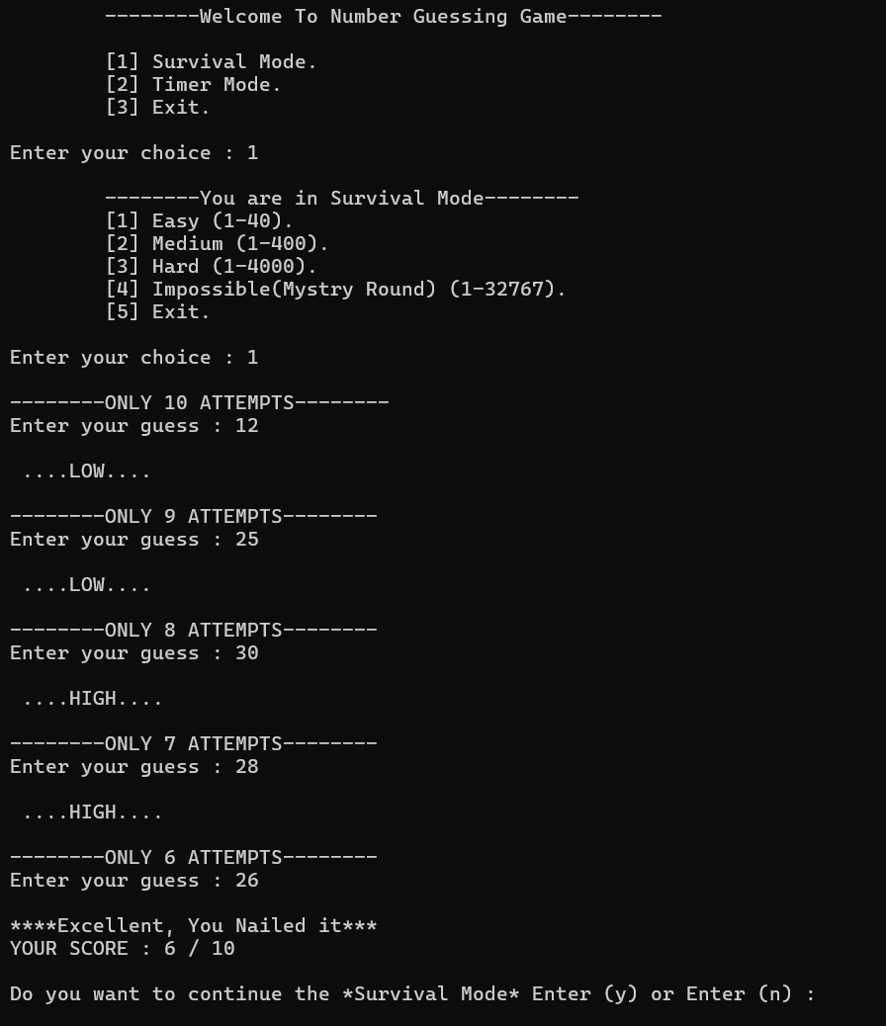

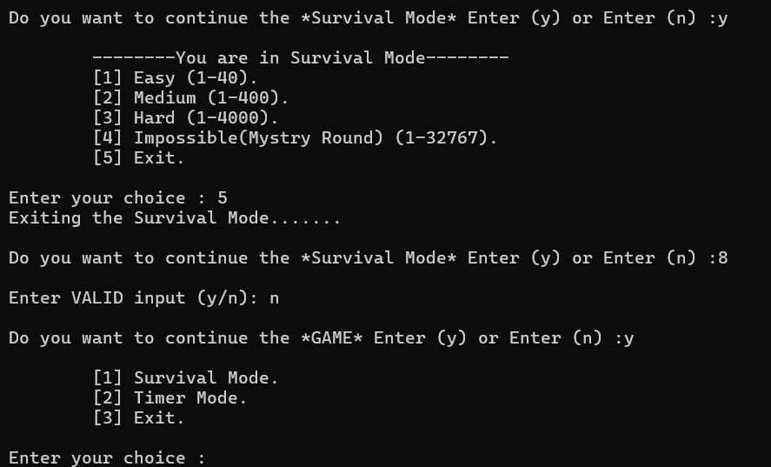
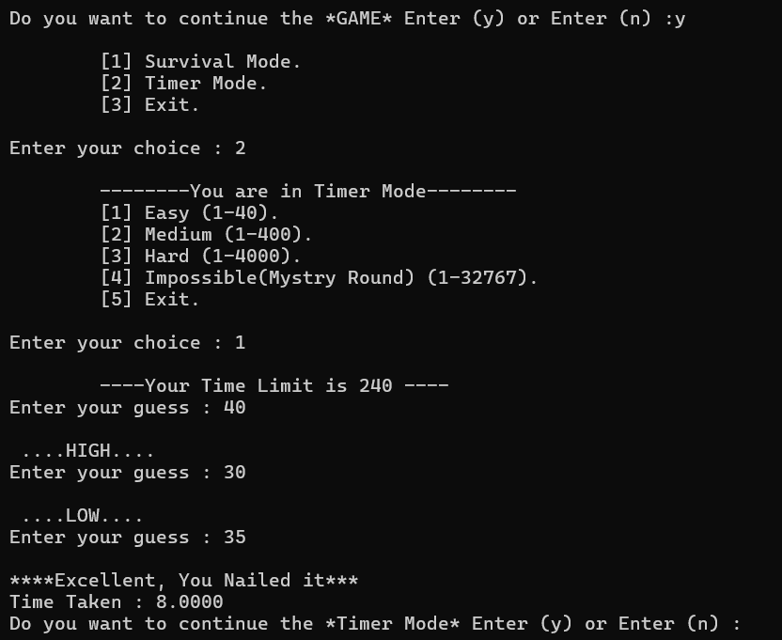
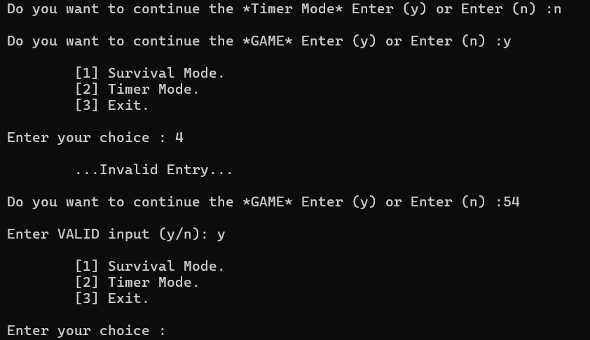
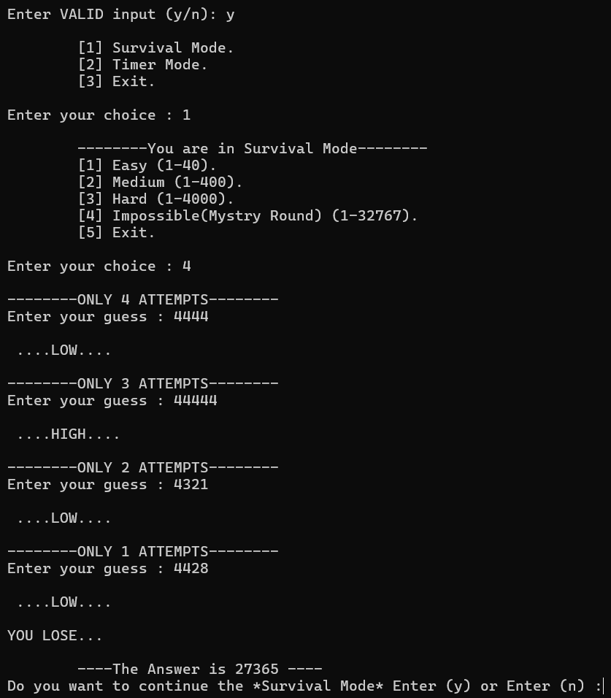
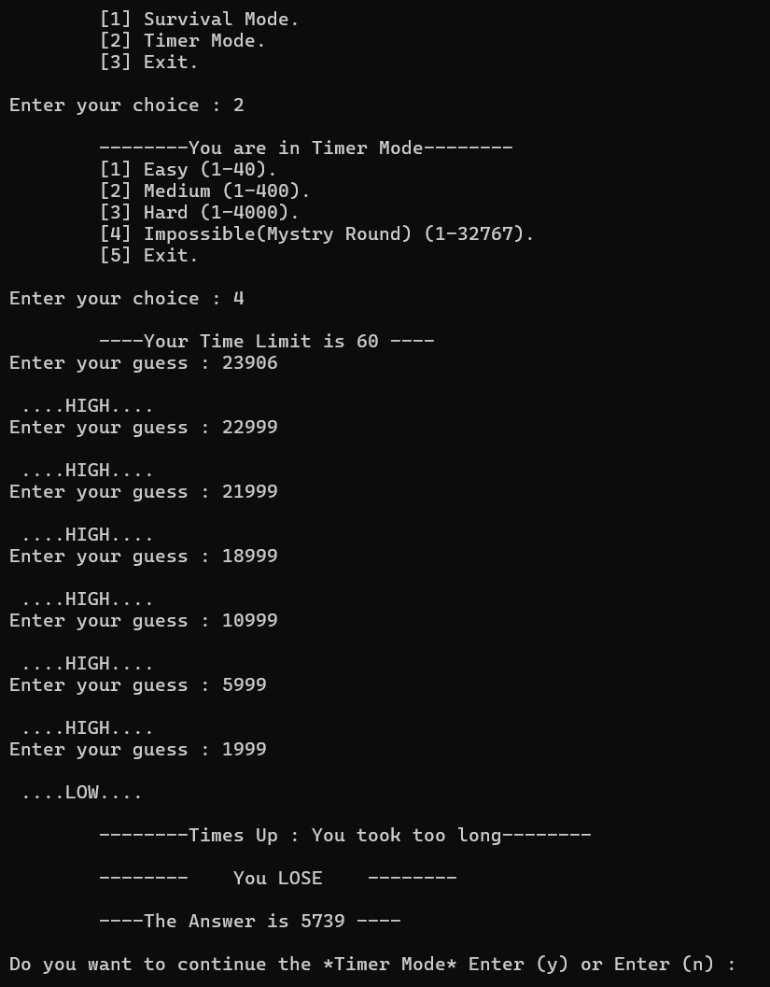

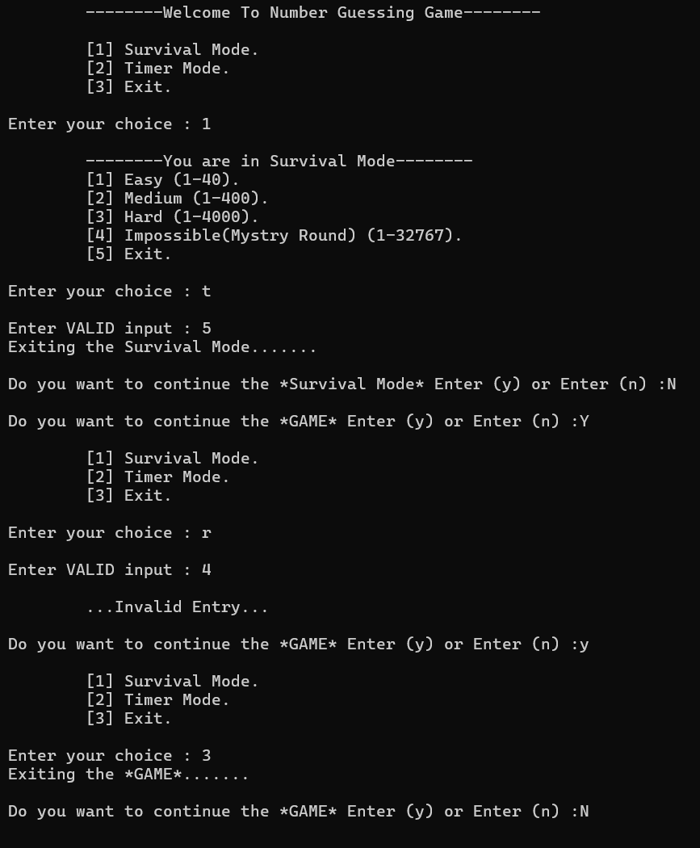

Program Ended…

